CE 4710/5710 Exams Study Guide
Fall 2019

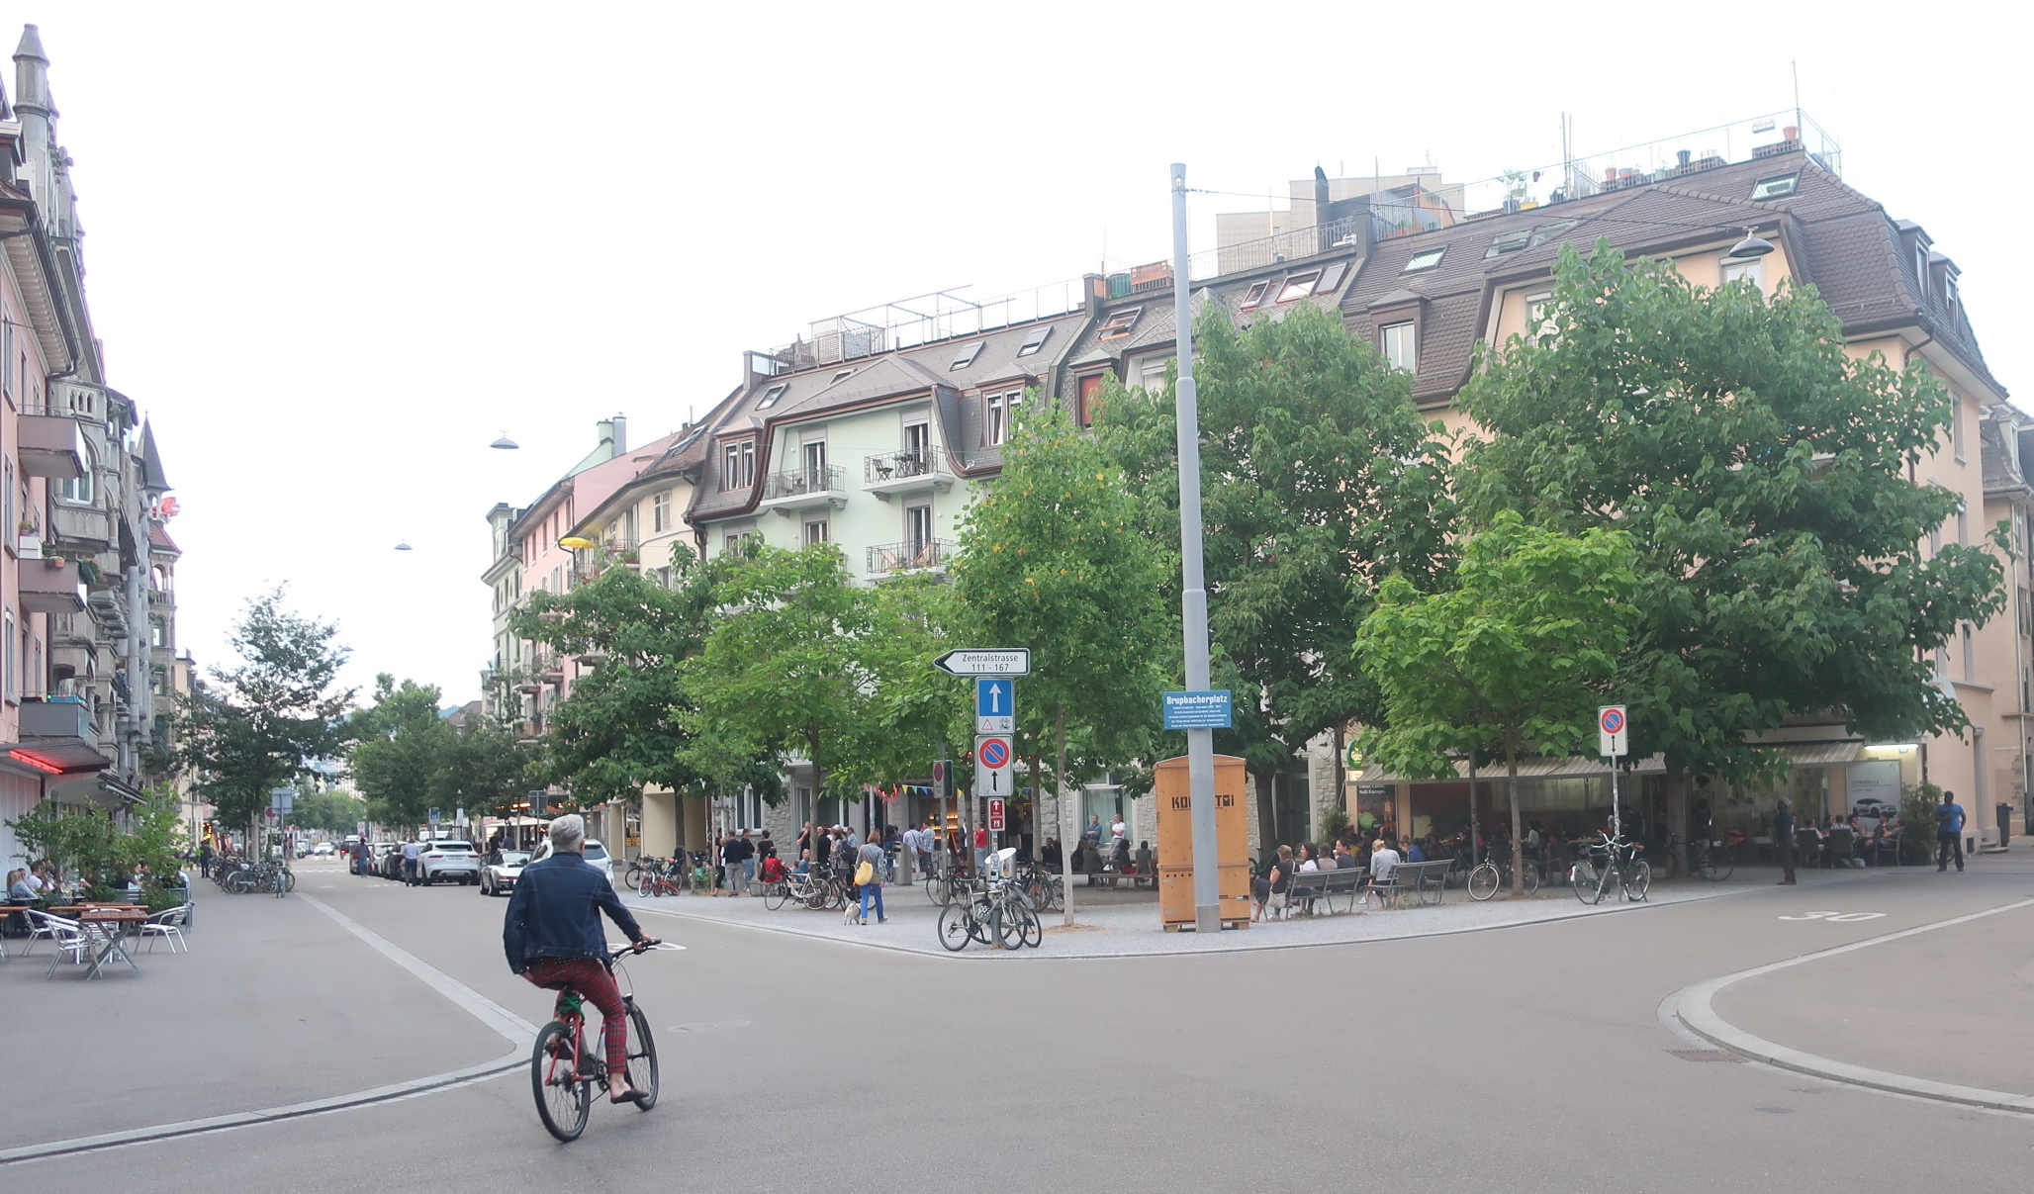

Basics of Effective Transportation Planning (Lecture 2 and Understanding Bias reading)
- Understand the difference between goals and objectives and know why the distinction is important.
- Understand the difference between growth and development.
- Have a good understanding of the range of environmental, social and economic issues that are directly affected by transportation planning decisions.
- Know how to characterize transportation impact according to Litman’s three levels of impact
- Understand the concept of induced traffic and the factors that cause it
- Understand the concept of ‘predict and provide’ and the associated problems and objections to this approach to planning
- Understand why it is important to consider qualitative factors in transportation, what are some of these factors, and why not considering them might distort the outcome of transportation planning
- Know why the difference between vehicle mobility, personal mobility and access is important in terms of determining the type of transportation system that we end up with.
- Understand the specific strategies that promote personal mobility over vehicle mobility
- Understand the specific strategies that can be used to improve access.
- Understand the importance of always linking transportation and land use planning.

Evolution of Cities (Lecture 3 and Marshall reading)
- Understand differences in physical form of urban places built before the 1950s and those built after 1950. These include differences in street design, street network design, building design and site design.
- Understand that terms such as city, suburbs, and urban are not necessarily tied to these physical forms. For example, two so-called suburbs might have very different physical forms.
- Know the various ways in which places built before 1950s was modified to be more car oriented.
- Understand the role of different transportation modes in influencing the physical form of urban places. Specifically, what is the physical form of those cities that were developed around walking, commuter rail, streetcars and motorcars, respectively?
- Understand how different urban form affects transportation choices.
- Know in general terms some of the factors that lead to large changes in the approach to building urban places from the 1950s onward.
- Understand the role of the philosophy called ‘Modernism’ in influencing the form of newer urban places.
- Know the pros and cons of cities that were influenced by the Modernist movement (or Modernism).

More on Transportation Planning (Lecture 4 and Mumford reading)
- Understand the significance and meaning of the idea that a good transportation system minimizes unnecessary transportation.
- Understand the factors that lead to the development of a car-based transportation system.
- Know the historic role of activists as part of the freeway revolution in cities such as San Francisco, Washington and Zurich.
- Know and understand the reason why citizens in Zurich voted against a subway system that would have replaced the streetcars.
- Know the specific recommendations in the Peoples’ Plan for transportation in Zurich.
- Know the advantages and drawbacks of auto-dependency (monochromatic transportation system) versus a multimodal transportation system.
- Understand the characteristics of a multimodal transportation system as described in this reading.
- Understand the role that parking plays in cities.
- Understand the importance of the question: Does parking induce driving?

Struggle for Bikes in Amsterdam (Lecture 5 and Jordan reading)
- Know the major milestones in the development of bikes
- Know some of the history of bikes in the Netherlands
- Know the significance of the ‘white bike’ movement in Amsterdam
- Know about the reason given by public officials for trying to make cities more car friendly.
- Know some of the changes that were needed to make cities more car friendly
- Know some of the cities where citizen activists were successful in stopping or slowing the trend to making the city more car friendly
- Know the motivations and reasons given by citizen activists for opposing making the cities more car friendly
- Know the significance of the ‘Anti-Child Murder Movement’

Making Transit Works (Lecture 6 and Walker reading)
- Know and understand Walker’s seven principles for an excellent transit system
- Know the specific factors that contribute to a transit system meeting each of Walker’s seven principles.
- Understand the features of a transit network that contributes to its attractiveness to users.
- Understand how different types of street networks and land use patterns supports or hinders effective transit.
- Understand why the lines on a transit network map is not enough to judge how good the transit system is – that we also need to know frequency and length of service.
- Know all the features that contribute to the speed of a transit service and understand that the vehicle speed is just one factor.
- Understand the role that fare collection plays in affecting a number of Walker’s principles.
- Understand factors that are important in integrating different modes of transit service.
- Understand why good and comfortable connections matters.
- Understand why ‘one ticket for all’ is important and why it is so difficult to implement.
- Know some of the elements of the Zurich transit system that makes it stand out as one of the best in the World.

Basis of Urban Street and Street Network Design (Lecture 7)
- Know and understand the significance of the following concepts i) designing effective networks ii) designing for vulnerable road users, iii) designing as a place
- Understand in a general sense how street networks have evolved over time
- Know the features that characterize this evolution in street networks
- Understand why street networks are important for travel and place making
- Know the role of the FHA in changing the type of street network that we build
- Know in a general sense how network characteristics affect traffic safety and mode choice
- Know and understand the seven characteristics of a sustainable street network
- Know and understand the significance of the meaning of the term vulnerable road user
- Know the main elements in designing for vulnerable road users
- Understand the role of speed for safety and convenience of different class of road users
- Know the factors contributing to a sense of place in design including issues of i) building orientation, ii) building design, iii) parking type and orientation, iv) block size and v) sense of enclosure

Sustainability and Auto-dependency (Lecture 8)
- Understand the importance of concept of sustainability for assess how well a transportation system is performing.
- Know the common way of conceptualizing sustainability as having 3 domains.
- Understand the concept of sustainability as a series of nested box and how and why that is different from the three-legged stool model.
- Understand the limitations of the three-legged stool model of sustainability.
- Understand how the nested box model of sustainability in rooted in the idea that the most important limitation to sustainability is the carrying capacity of the biosphere.
- Know Haughton’s Five Equity Principles of Sustainability and how they are related to transportation/land use goals.
- Know Newman’s definition of auto-dependency and the significance of the 30 minutes travel budget.
- Know some of the specific conflicts between auto-dependency and sustainability especially in terms of the Equity Principles.

